1. 配置

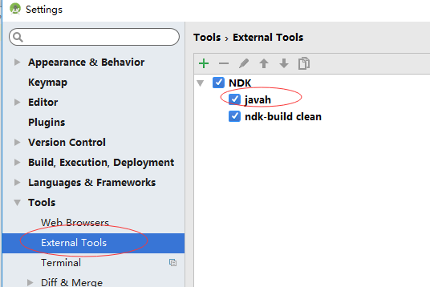

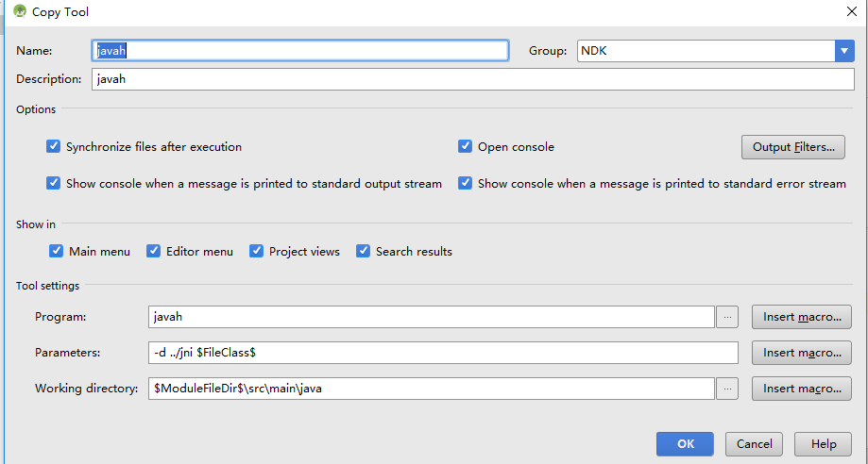

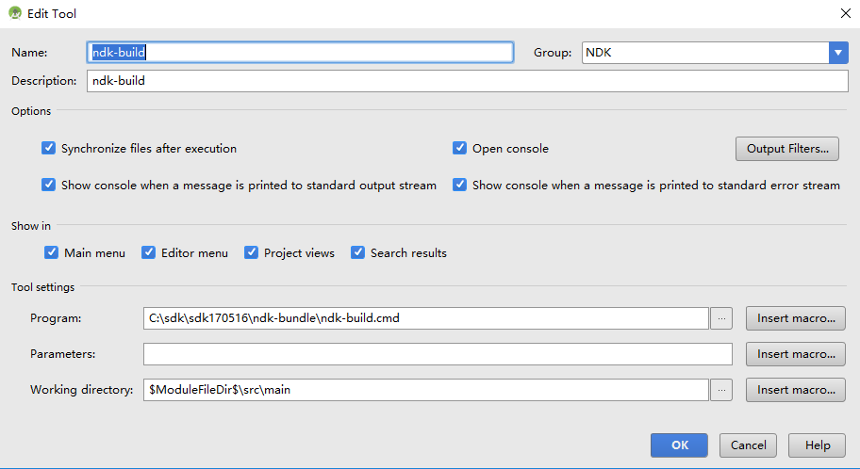

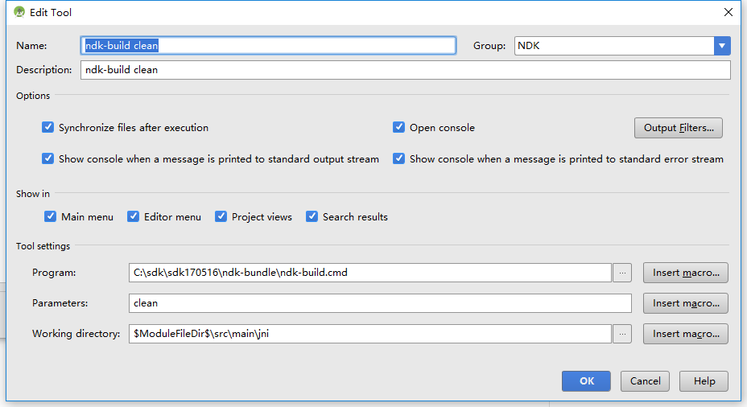

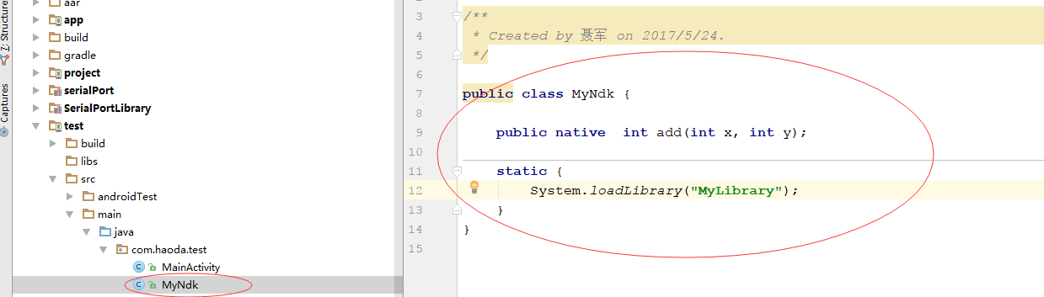

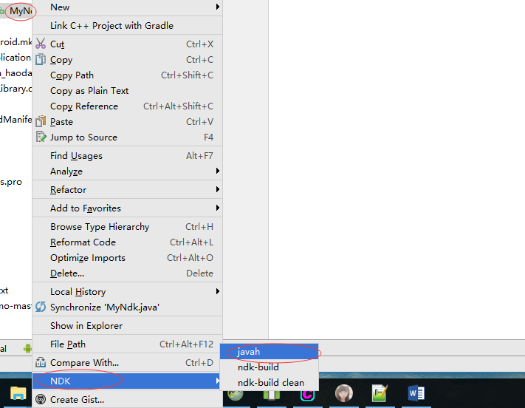

编译cpp及mk

MyLibrary.cpp

#include "com_haoda_test_MyNdk.h"

JNIEXPORT jint JNICALL Java_com_haoda_test_MyNdk_add

(JNIEnv * env, jobject obj,jint a,jint b){

return a+b;

}

Android.mk

LOCAL_PATH := $(call my-dir)

include $(CLEAR_VARS)

LOCAL_MODULE := MyLibrary

LOCAL_SRC_FILES =: MyLibrary.cpp

include $(BUILD_SHARED_LIBRARY)

Application.mk

APP_MODULES := MyLibrary

APP_ABI := arm64-v8a armeabi armeabi-v7a

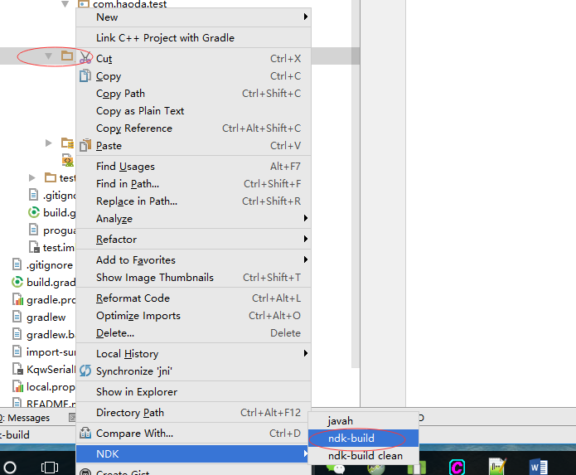

App下的gradle里面加入

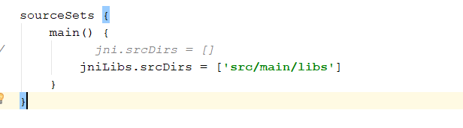

sourceSets {  
 main() {jniLibs.srcDirs = [**'src/main/libs'**]  
 }  
 }

project的gradle.properties下加入

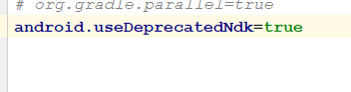

**android.useDeprecatedNdk**=**true**